**Ideation Phase**

**Define the Problem Statements**

| Date | 30 October 2025 |
| --- | --- |
| Team ID | NM2025TMID03233 |
| Project Name | Optimizing User, Group, and Role Management with Access Control and Workflows |
| Maximum Marks | 2 Marks |

**Customer Problem Statement Template:**

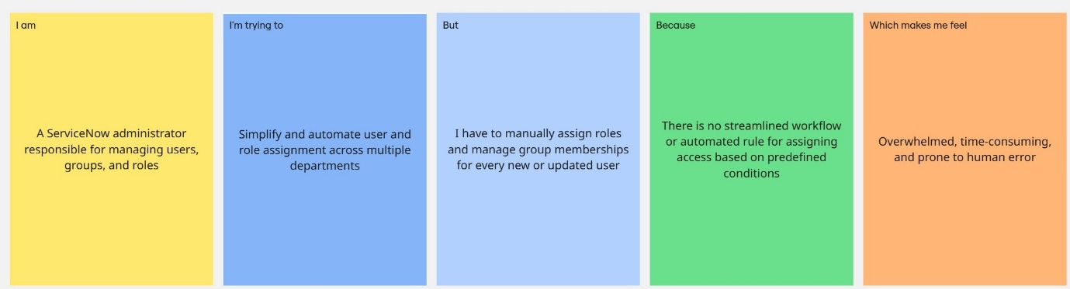

## Problem Statement Table:

| **Problem Statement (PS)** | **I am (Customer)** | **I’m trying to** | **But** | **Because** | **Which makes me feel** |
| --- | --- | --- | --- | --- | --- |
| PS-1 | A ServiceNow administrator responsible for managing users, groups, and roles | Simplify and automate user and role assignment across multiple departments | I have to manually assign roles and manage group memberships for every new or updated user | There is no streamlined workflow or automated rule for assigning access based on predefined conditions | Overwhelmed, time-consuming, and prone to human error |
| PS-2 | An IT manager who needs to ensure secure and role-based access within the organization | Implement proper access controls and approval workflows for sensitive data and actions | Access permissions are not consistently managed, and approvals are handled manually. | The absence of an automated access control system increases security risks and delays operations | Concerned about data security and lack of operational efficiency |